**PROJECT DESIGN PHASE - II**

**TECHNOLOGY ARCHITECTURE**

|  |  |
| --- | --- |
| Date | **30 October 2022** |
| Team ID | **B3-3M5E** |
| Project Name | **Personal Assistance for Seniors Who Are Self-Reliant** |
| Maximum Marks | **4 Marks** |

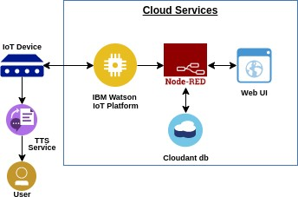**Technical Architecture:**

**Table-1: Components & Technologies:**

|  |  |  |  |
| --- | --- | --- | --- |
| S No | Component | Description | Technology |
| 1.  2. | **User Interface** | **Mobile App** | **HTML, CSS,**  **JavaScript**  **Python** |
| **Application Logic-1** | **Mobile App to enter the Medicine**  **Details weekly** |
| 3. | **Application Logic-2** | **Gets the medication data from database** | **IBM Watson IoT API**  **Call data** |
| 4. | **Application Logic-3** | **Converts the text to speech to pronunciation for the user** | **IBM Watson**  **Assistant** |
| 5. | **Database** | **Medication time and tablets name on daily and** | **MySQL** |
| 6. | **Cloud Database** | **Call the data IBM Cloud is used and user login credentials** | **IBM DB2, IBM**  **Cloud** |
| 7. | **File Storage** | **App code and IoT credentials are stored and API keys** | **IBM Block Storage** |
| 8. | **External API-1** | **To get the medicine box status**  **Open or not** | **IBM box status API** |
| 9. | **External API-2** | **To get the login credentials in IBM**  **DB2** | **Username and**  **Password API** |
| 10. | **Machine Learning**  **Model** | **To convert the text into speech for voice command the tablet**  **details** | **Text to speech** |
| 11. | **Infrastructure**  **(Server / Cloud)** | **To host the server and application** | **Cloud Foundry,**  **Node Red** |

**Table-2: Application Characteristics:**

|  |  |  |  |
| --- | --- | --- | --- |
| S.N o | Characteristics | Description | Technology |
| 1. | **Open-Source**  **Frameworks** | **To develop the application interface, we use**  **MIT App Inventor** | **MIT APP**  **INVENTOR** |
| 2. | **Security**  **Implementations** | **To secure the users login credentials and personal information** | **SHA-256, OWASP** |
| 3. | **Scalable Architecture** | **To scale the application database** | **IBM Auto scaling** |
| 4. | **Availability** | **To make use the application and data are available 24/7** | **IBM Cloud load balancer** |
| 5. | **Performance** | **To increase the performance the application in hosted in the high- performance instance** | **IBM instance** |